Students Logging into ConnectED

(My Math and Glencoe Course 1, 2, and 3)

There are a couple of ways for students to access their McGraw-Hill ConnectED account.

1. Login to Infinite Campus using the same username and password that is used for logging in to the computer.

On the student portal, click on **CUSD Student Links.**



A new tab or window will open up with the available student links. Click on the **Clever** application.

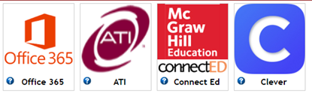

It will ask you to log in to **Clever**.

*The username for a student is [**sid#@s.cusd80.com**](mailto:sid#@s.cusd80.com). The password is the **same one you use for the computer**.

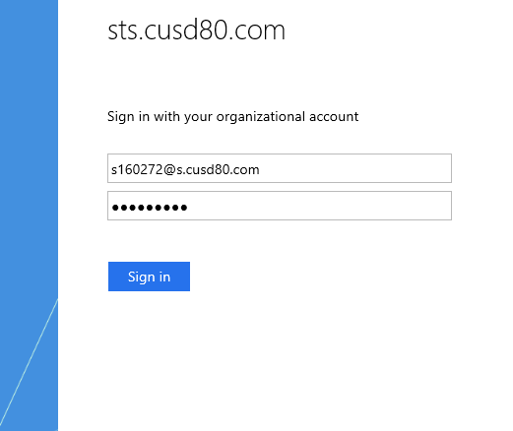

You will click on the **McGraw-Hill Education App** and it will direct you to your ConnectED account.

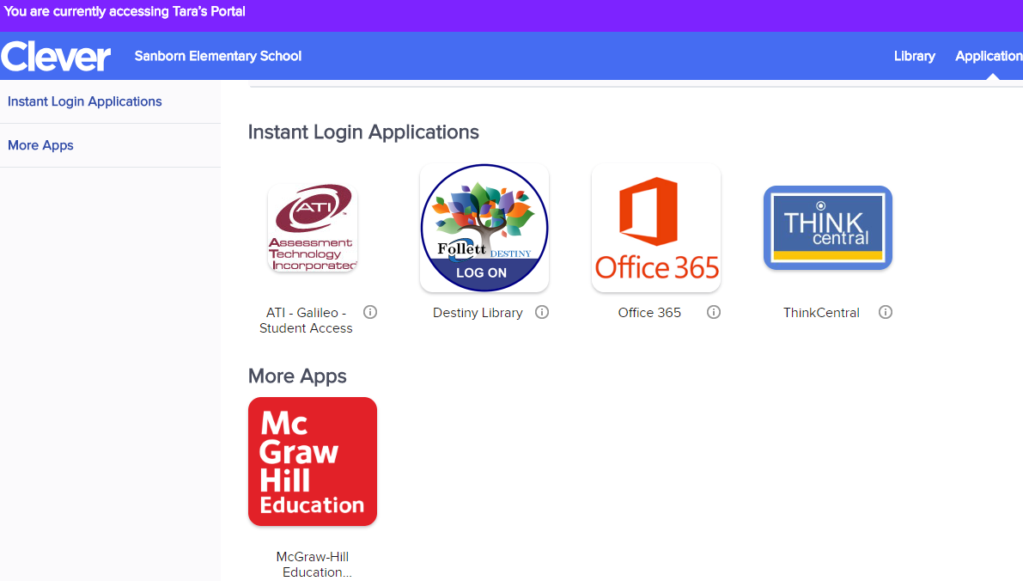

1. At school, you can choose the **Clever** icon from the desktop.

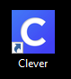

*The username for a student is [**sid#@s.cusd80.com**](mailto:sid#@s.cusd80.com). The password is the **same one you use for the computer**.



You will click on the **McGraw-Hill Education App** and it will direct you to your ConnectED account.



1. From home, go to the **Chandler** website at **cusd80.com.**

Click on **Parents & Students** that is located across the yellow bar.

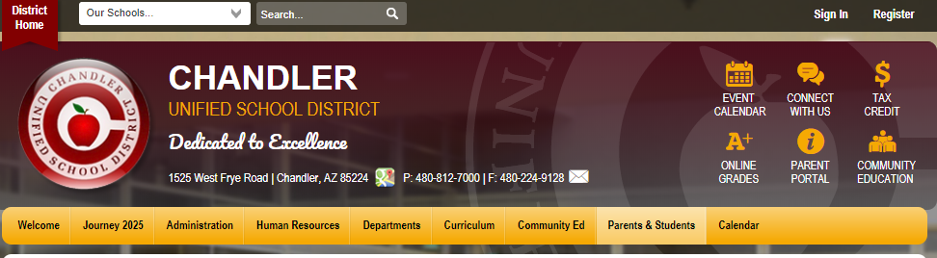

Click on **Technology Resource Links for Students, Parents.**

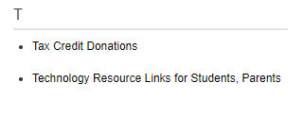

On this page, you will find the **Clever** icon. Click on the icon, and then log in to your Clever account.

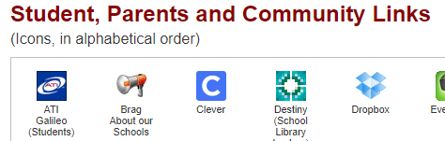

*The username for a student is [**sid#@s.cusd80.com**](mailto:sid#@s.cusd80.com). The password is the **same one you use for the computer**.



You will click on the **McGraw-Hill Education App** and it will direct you to your ConnectED account.

